**Fatima Jinnah Women University**

Department of Software Engineering

**LAB 10**

**Name:** Raifa Khalid

**Reg. no:** 2020-BSE-024

**Section:** A

**Semester:** Fourth

**Course:** Data Base (LAB)

**EXAMPLES:**

*Primary Key Constraint:*

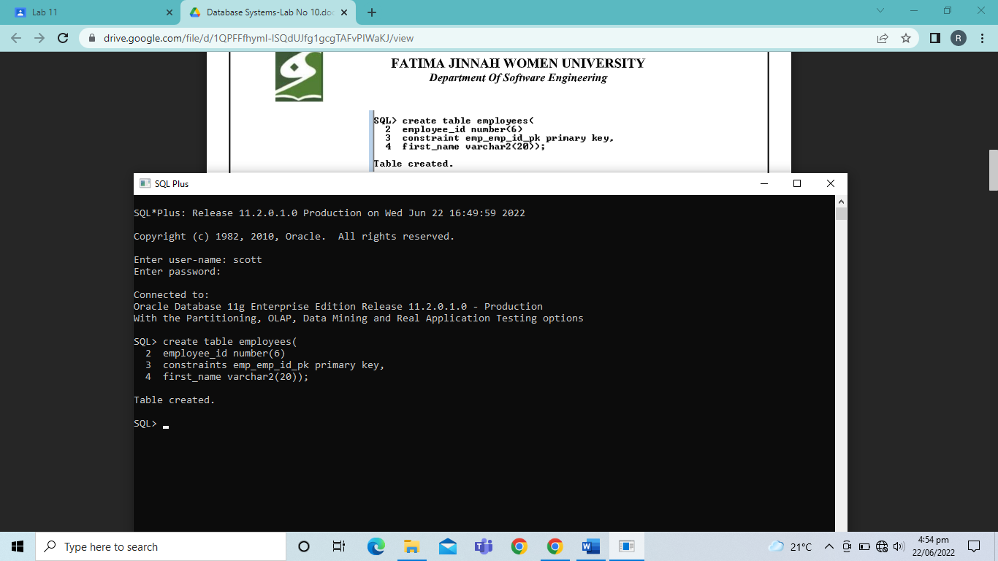

*Not Null Constraint:*

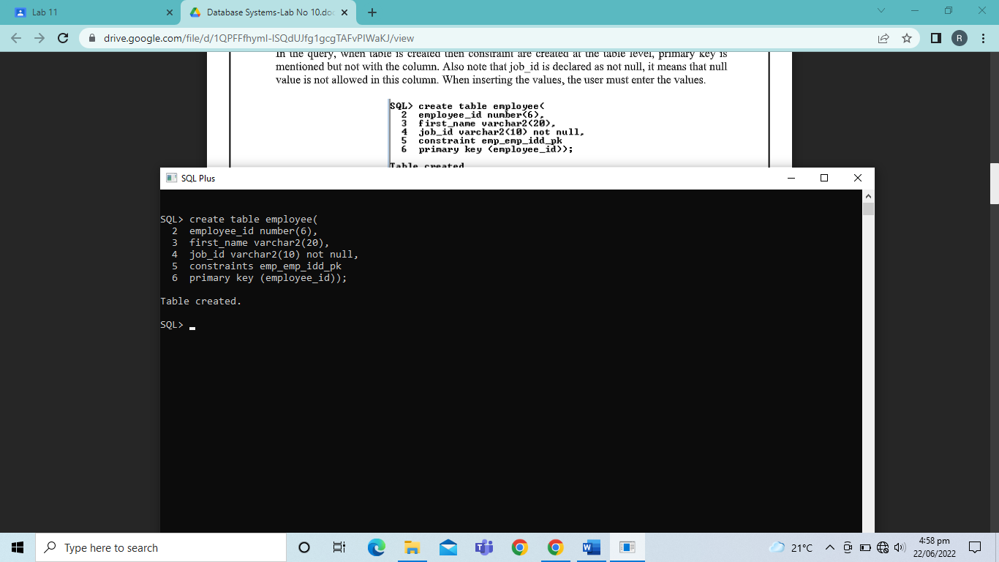

*UNIQUE Constraint:*

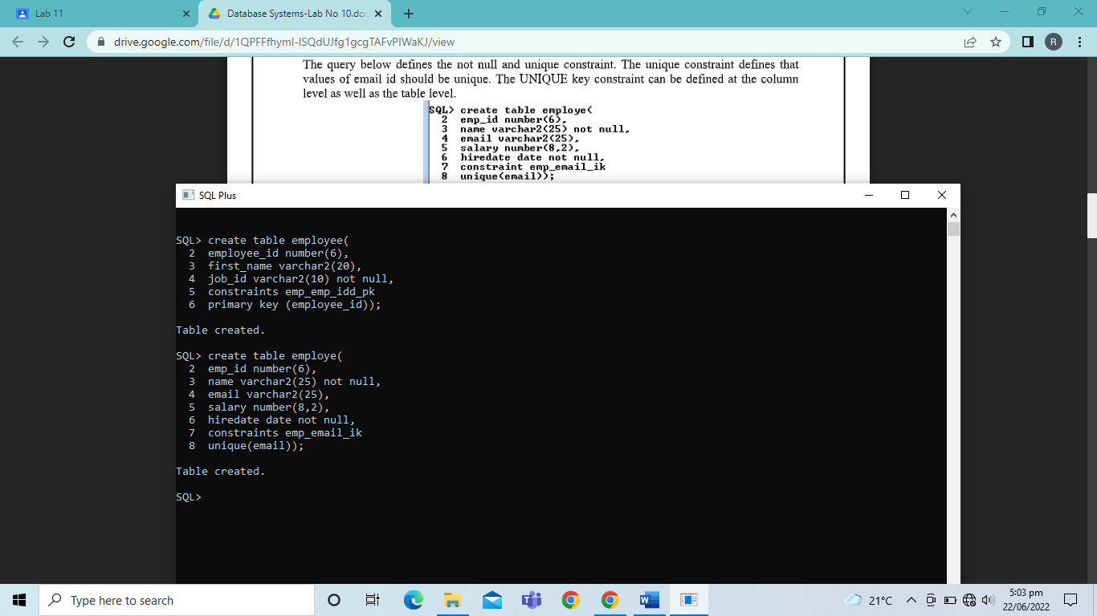

*Foreign Key Constraint:*

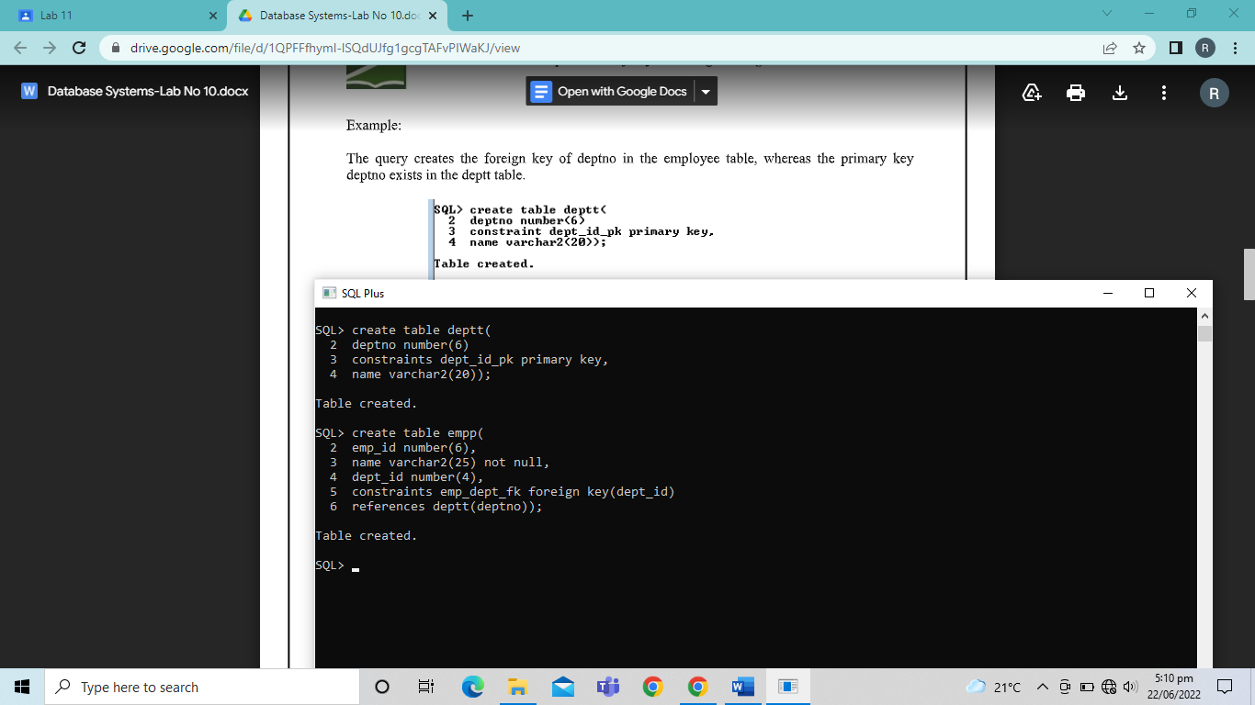

*Check Constraint:*

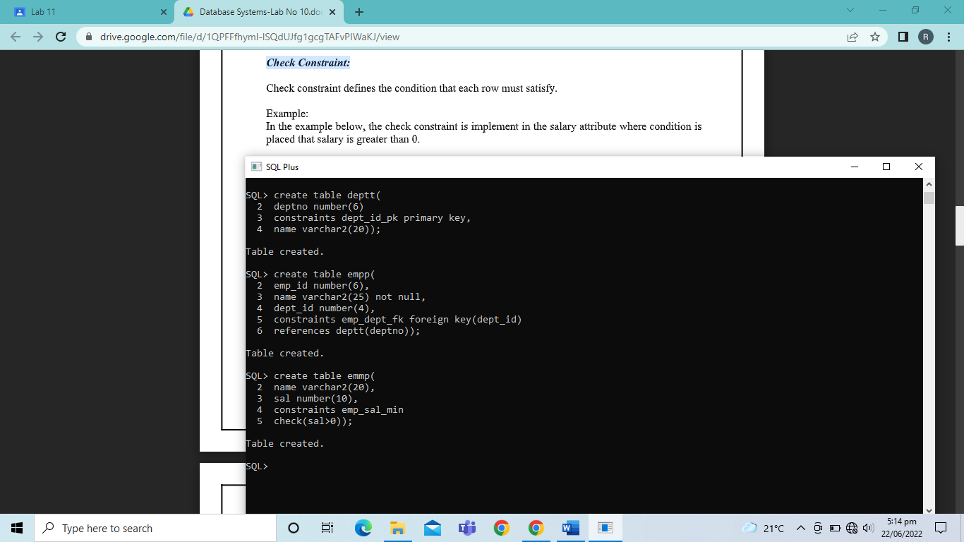

*Example Including All Constraints:*

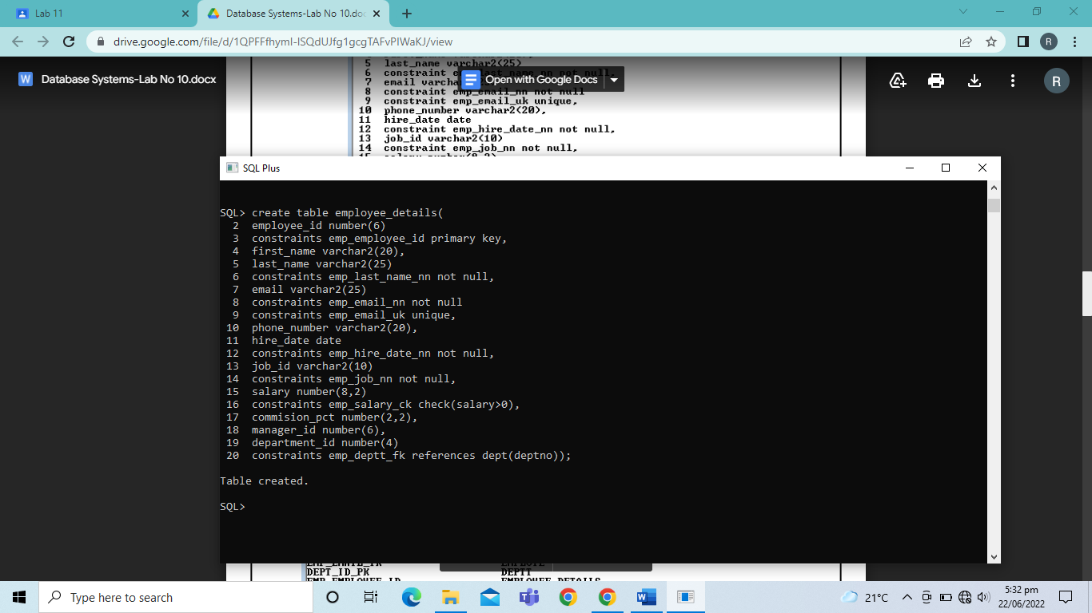

*View Constraint:*

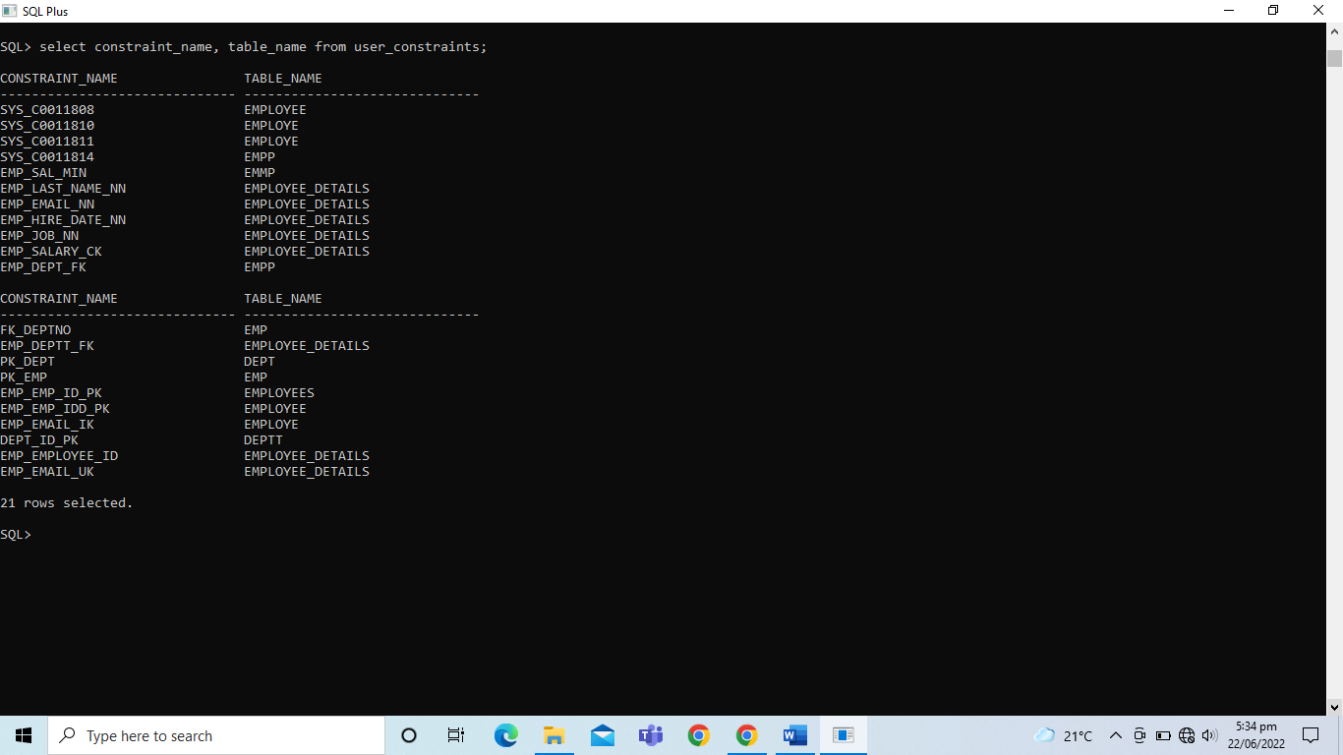

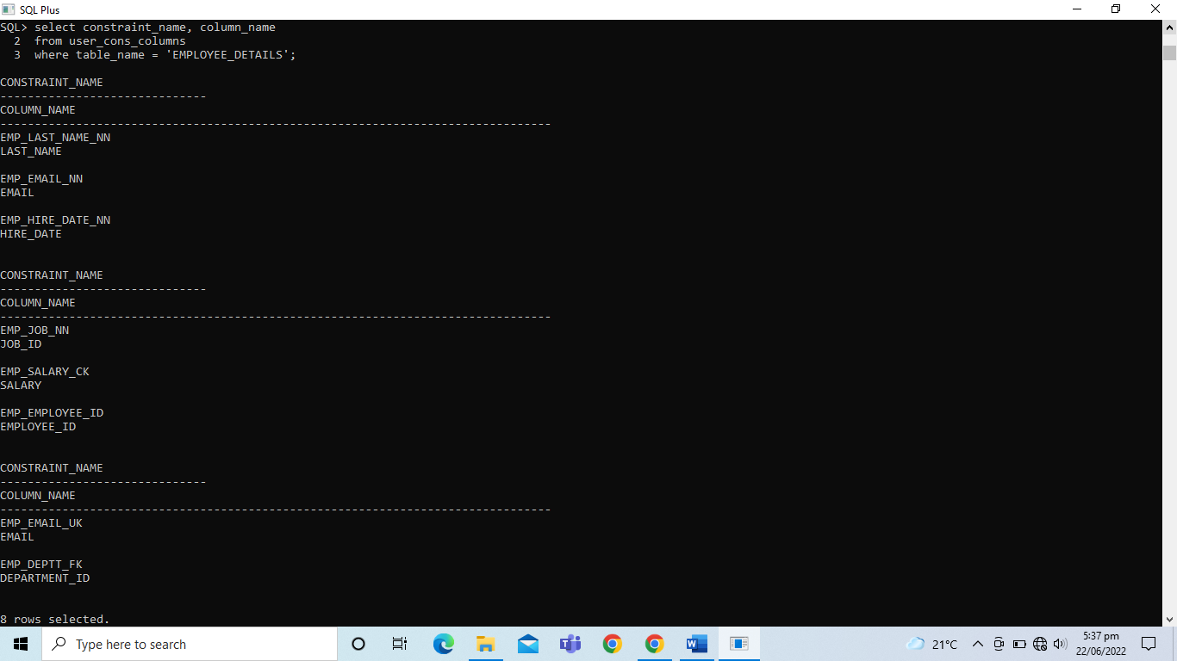

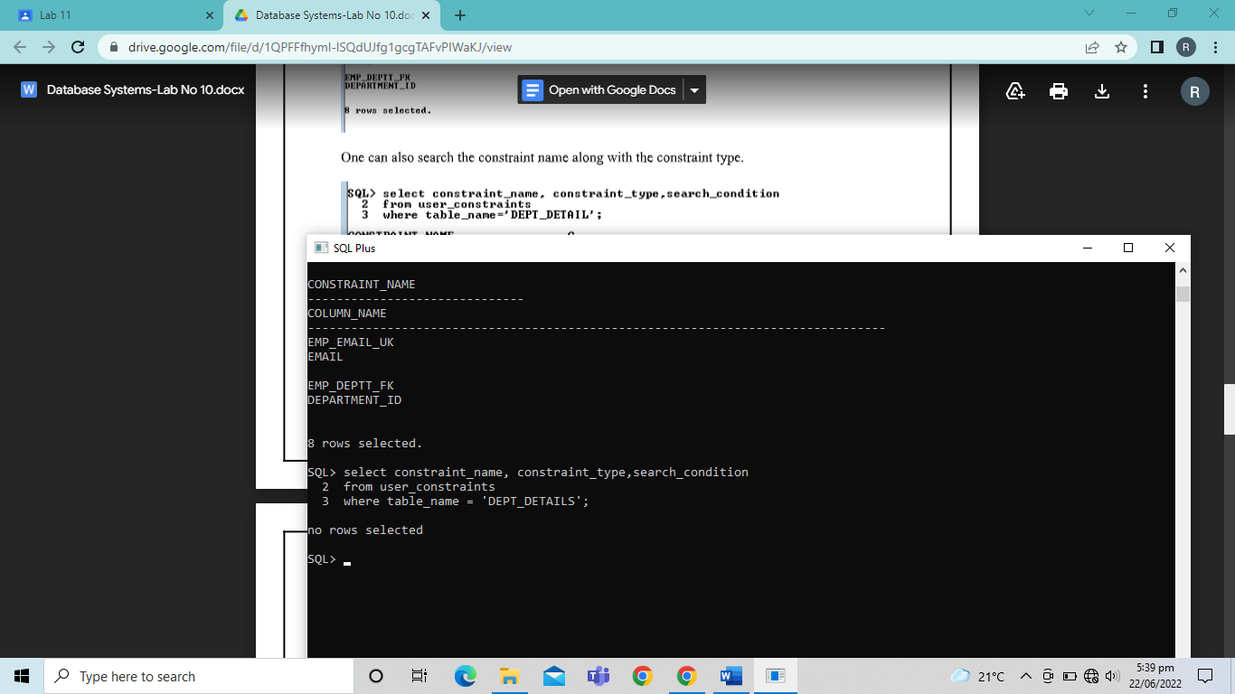

*Dropping Constraint:*

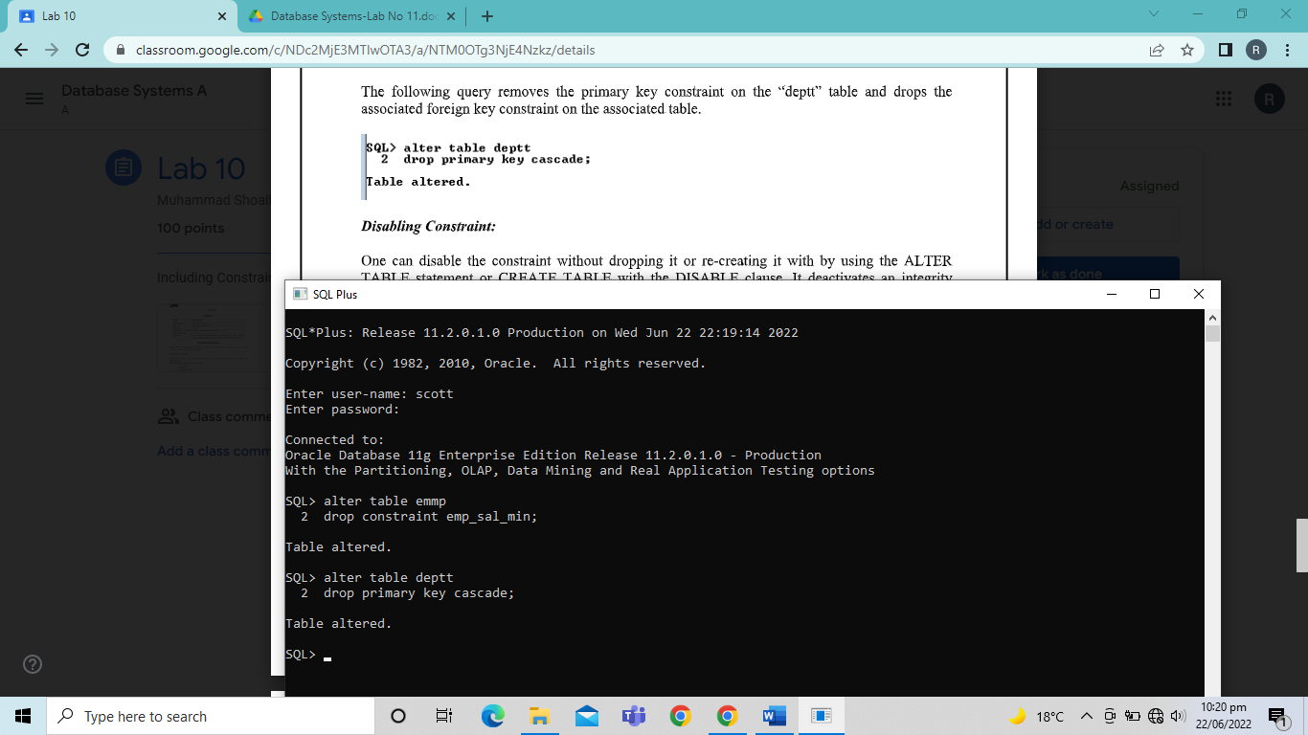

TASKS

1. Add a table level primary key constraint to the “Employee_Detail” table on the ID column. The constraint should be named at creation. Name the constraint my_emp_id_pk.

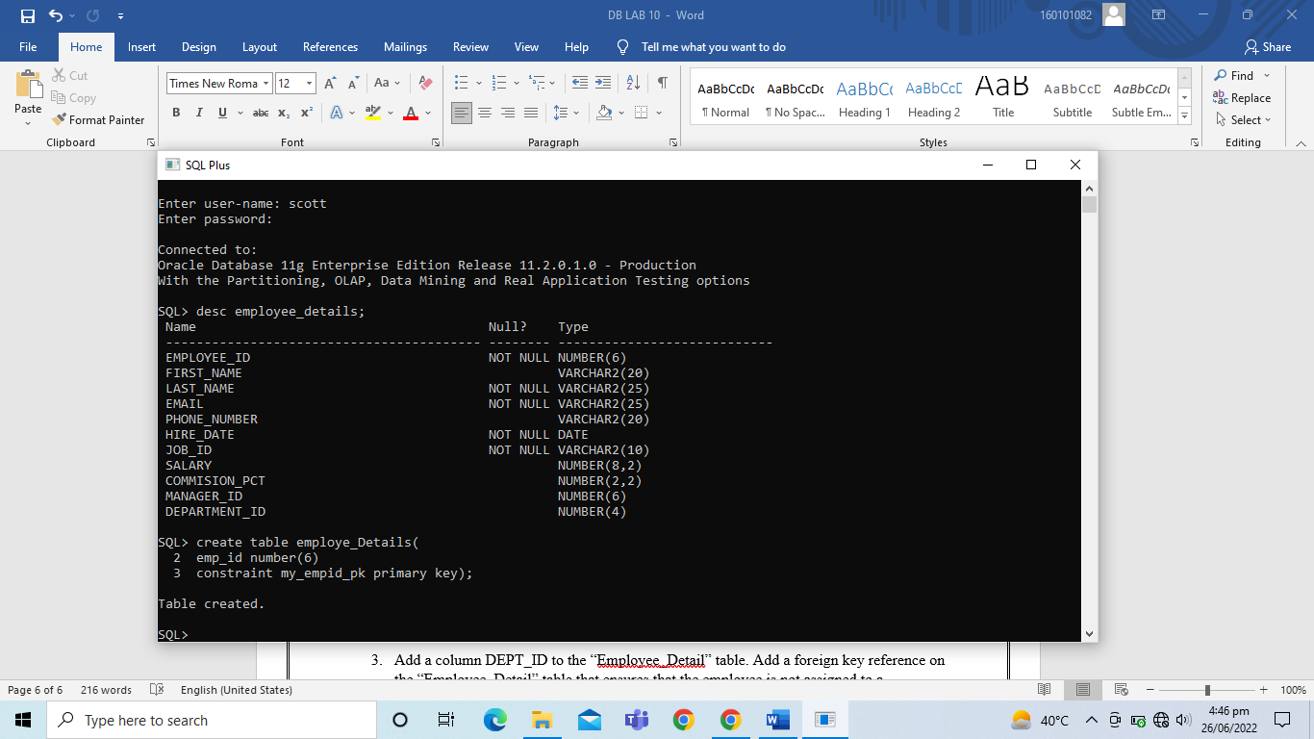

1. Create a PRIMARY KEY constraint to the “DEPT_DETAIL” table using the ID column. The constraint should be named at creation. Name the constraint my_deptid_pk.

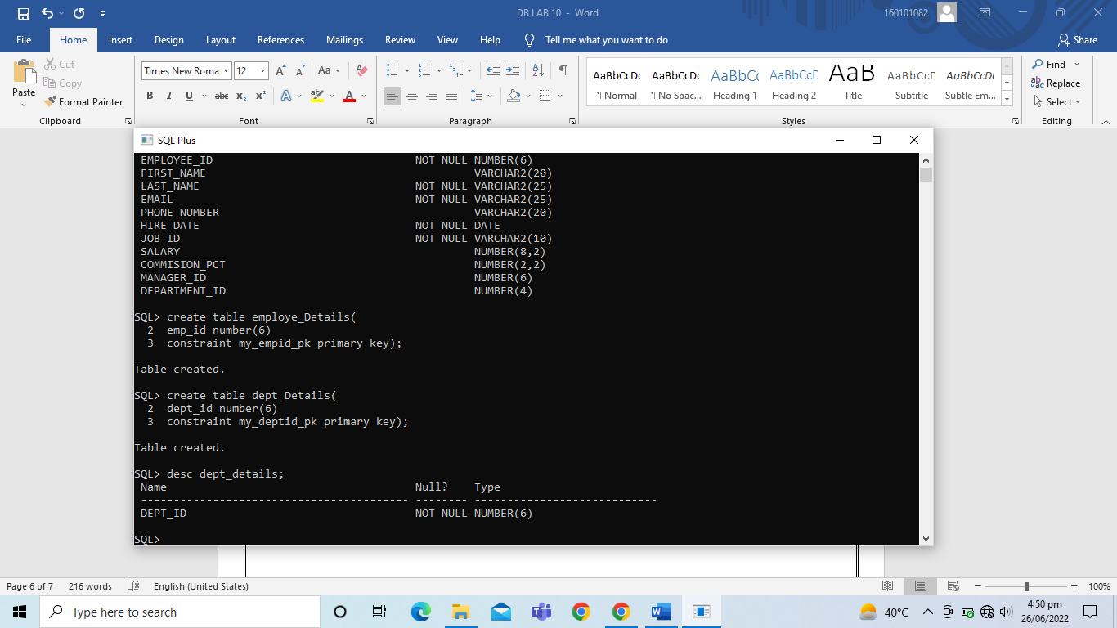

1. Add a column DEPT_ID to the “Employee_Detail” table. Add a foreign key reference on the “Employee_Detail” table that ensures that the employee is not assigned to a nonexistent department. Name the constraint my_emp_dept_id_fk.

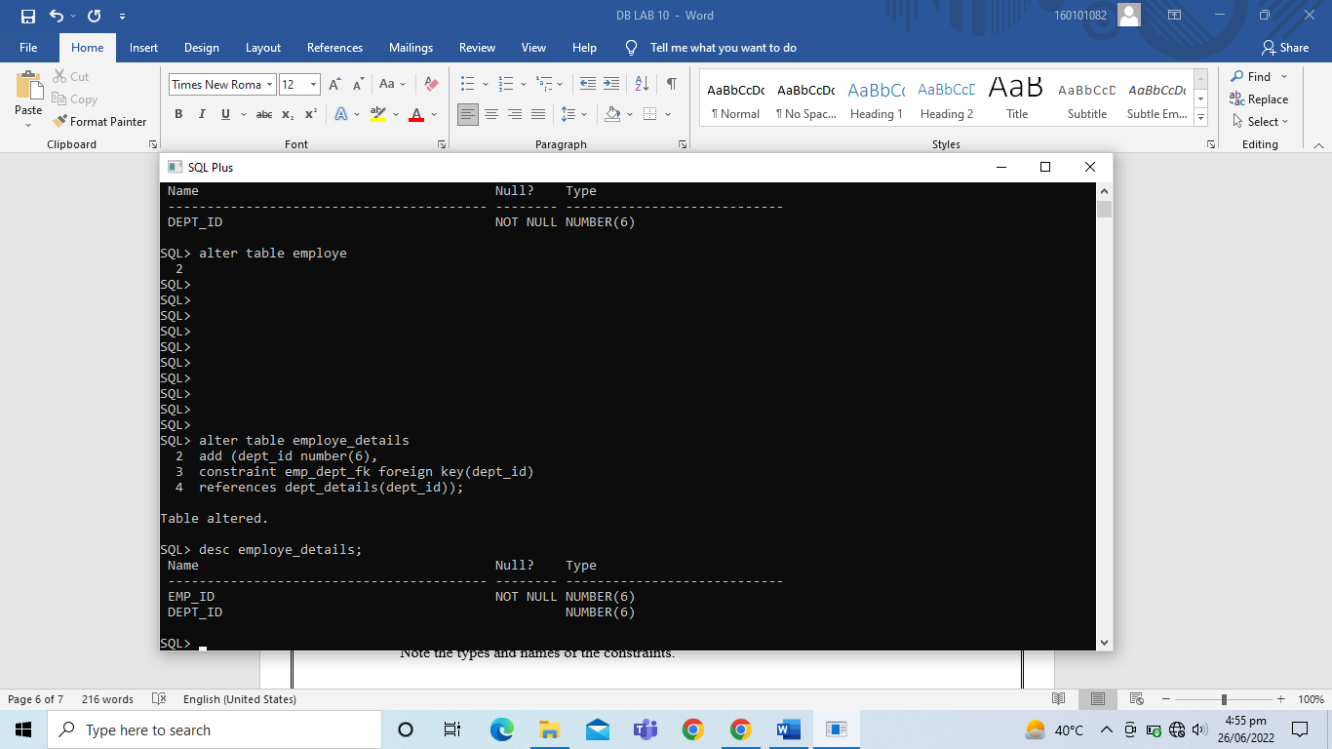

1. Conform that the constraints were added by querying the USER_CONSTRAINTS view. Note the types and names of the constraints.

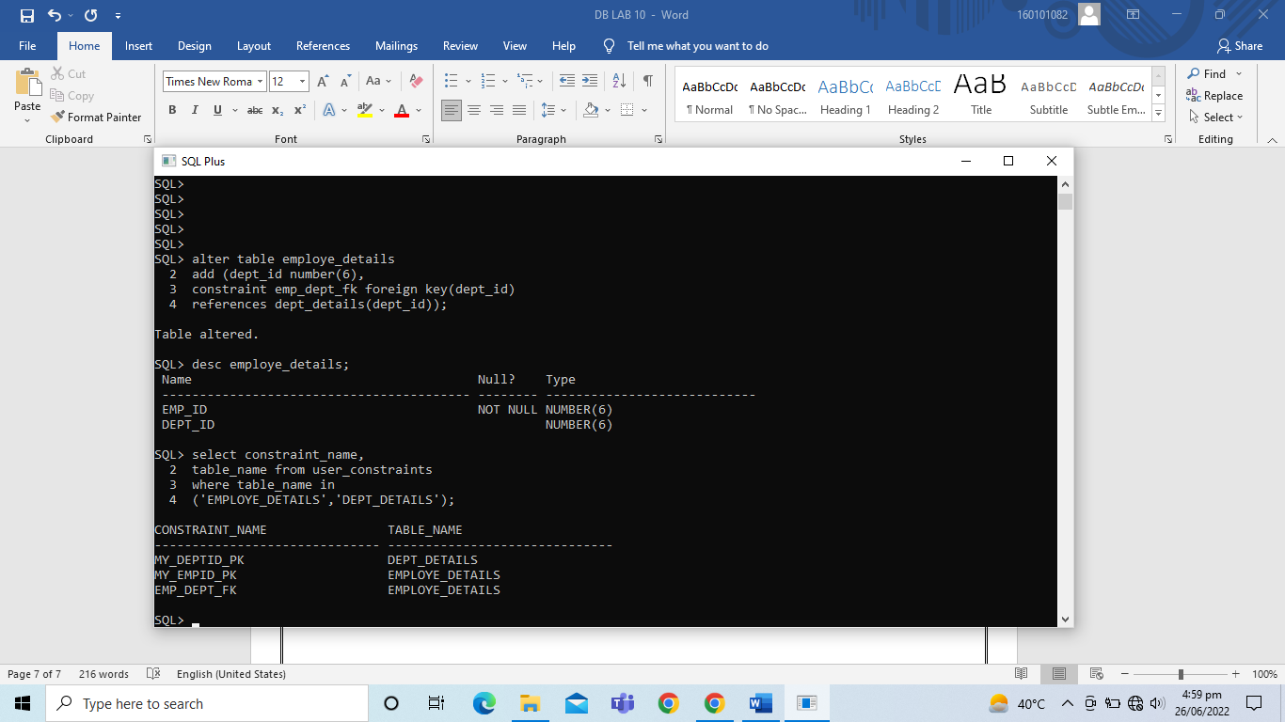

1. Display the object names and types from USER_OBJECTS data dictionary view for the “Employee_Detail” and “Dept_Detail” tables. Notice that the new tables and a new index were created.

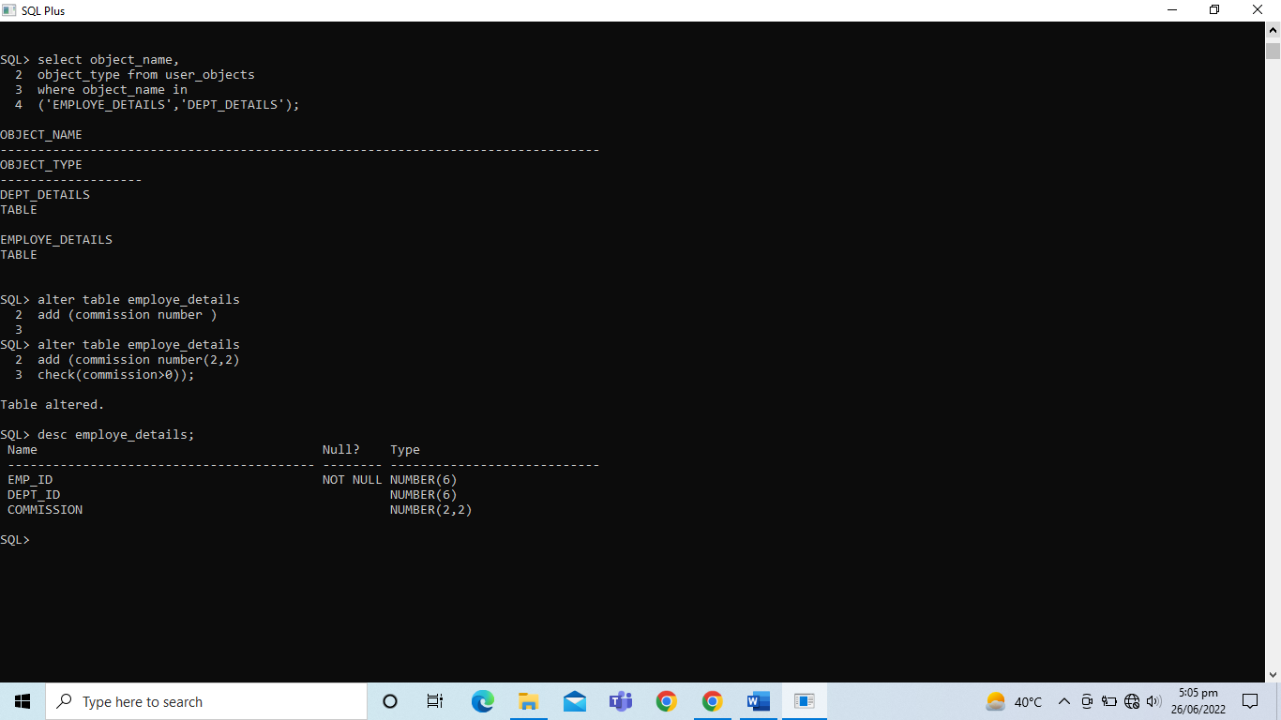

1. Modify the “Employee_Detail” table. Add a COMMISION column of NUMBER data type, precision 2, scale 2. Add a constraint to the commission column that ensures that a commission value is greater than zero.

